Rough Draft

J. Ted Hillert

2023-10-02

Table of Contents

Abstract 2

Introduction 3

Round Bald 6

Methods 7

Study Site 7

Field Methods 8

Soil Seed Bank 9

Analysis 11

Results 12

Discussion 14

References 18

Figures 20

# Abstract

On the borders of Cherokee National Forest in Tennessee and Pisgah National Forest in North Carolina lie the balds of Carver’s Gap - a rare and unique ecosystem subtype that hosts a high proportion of endemic flora. These balds are experiencing woody encroachment from the surrounding forest and from *Rubus* species threatening alteration from a grass bald to a heath bald. In 2020, a survey of the balds of Carver’s gap was conducted following 30 years of mowing management. Mowing was shown to reduce the spread of *Rubus* species and showed a positive effect on graminoid cover with frequent disturbance. However, they also indicate that *Rubus* is present in dense patches and in the undergrowth across the balds. In February of 2022, a low-intensity ground fire burned approximately 9.7 hectares of area on Round bald, the first bald on Carver’s Gap. This study surveyed vegetation at the functional level - *Rubus*, grass, sedge, rhododendron, fern, forb, moss, rock, and bare ground - using a 1-meter square quadrat divided into 100 equal sized squares. Vegetation type was visually determined in each square to reach 100% cover for each plot. A total of 99 plots were measured along the first four transects reestablished by Stokes and Horton (2022). In 2022, I examined the vegetation composition four months post fire at the plot level to determine density of *Rubus* and grass species on the bald. Two soil seed bank samples were taken in July of 2022 and January of 2023, the first underwent seedling emergence trial, while the latter underwent seedling emergence and seed extraction trials. Overall, fire had a generalizing effect on the vegetation composition. Ultimately the fire was too low intensity to cause a strong effect on the vegetation composition of the bald, however *Rubus* responded more favorably to fire than did grass. This represents a continued management concern of control of *Rubus* on the balds of Carver’s Gap.

# Introduction

Upper montane treeless meadows - balds - host high proportion of endemic species, panoramic views of the landscape, and high ecotourism value (Gersmehl 1970, Murdock 1986, Hamel and Somers 1990). Balds are important for the ecosystem services they provide; provisioning services, soil erosion protection, carbon sequestration, water flow regulation, pest control, pollination, habitat for migratory species, gene pool protection, and cultural services for recreation and art (Tokarczyk 2017). Many balds are present above 1,400 meters in elevation and occur in the Southern Blue Ridge Physiographic Province, while any bald can exist on a rock outcrop above 1,200 meters in elevation (Gersmehl 1970). Balds are distributed along the southern Appalachian Mountain range through Virginia and globally with sites in Poland, Siberia, Ukraine, and Australia (Tokarczyk 2017). Balds can be further divided into subtypes of grass, dominated by dense herbaceous vegetation and the presence of various forbs - or heath balds dominated by evergreen ericaceous shrubs in rocky soils. Grass balds along the Southern Appalachian mountains are dominated by Mountain Oatgrass (*Danthonia compressa*) and *Carex spp.* with various forbs present, such as Roan mountain goldenrod (*Solidago roanensis*), three-toothed cinquefoil (*Sibbaldiopsis tridentata*) and false bugbane (*Trautvetteria caroliniensis*) (Fleming et al. 2001, NCNHP n.d.). These meadows are often surrounded by forests of red spruce (*Picea rubens*), Fraser fir (*Abies fraseri*), beech (*Fagus grandifolia*), and yellow birch (*Betula alleghaniensis*) (Stokes and Horton 2022). Balds have been in global decline due to encroachment of the surrounding forests and woody vegetation. This decline of balds represents a widespread conservation and ecological restoration concern as the loss of one bald represents the loss of an entire ecosystem otherwise unrepresented on the landscape (Copenheaver et al. 2009).

The United States Forest Service (USFS) acquired some of the Southern Appalachian bald lands in the late 1920s after which active management and general recreation ceased (Lindsay and Bratton 1979). This led to shrub succession in the late 1930s and a management problem in the 1950s (Lindsay and Bratton 1979, Lindsay and Bratton 1980). Following management cessation, the range of grass balds along the Southern Appalachian Mountains has shifted since the study by Murdock (1986), who had surveyed round balds in the 1980s. A repeated survey of the balds of Carver’s Gap in 2020 by Stokes and Horton (2022) examined the vegetation of Round bald, Jane bald, and parts of Grassy Ridge Bald. The cover of *Rubus allegheniensis* and *Rubus canadensis* (*Rubus*), two primary native invasive species are still present in dense patches on the balds and in the undergrowth across the balds. Appropriate management regime is uncertain considering uncertainty over original management regime and effects on endemic flora. Some balds were cleared by Native Americans for hunting, pasturing livestock, and home and land use or by European settlers for timber and pasturing livestock in the spring and summer seasons (Lindsay and Bratton 1979) Other balds were driven by a climate-herbivore change in the landscape, making it a natural ecosystem. This climate-herbivore change was caused by Pleistocene glaciation opening patches in the timberline that were subsequently grazed on by large herbivores and megafauna to maintain the open state (Weigl and Knowles 1995, 2014).

Bald management within the Southern Appalachian Mountains varies by managing agency and bald history, with most practices promoting mowing or grazing, and few instances of fire or clearing. When used, fire must be high intensity or high duration to provide a significant effect against woody encroachment (Lindsay and Bratton 1980). Germination requirements of the invasive genus *Rubus* include scarification - some damage to the seed must occur for the seed to germinate, fire can provide that damage and could possibly increase growth the following season (Davies 1998). Sufficiently hot or lengthy burns have the potential to prevent the growth of blackberry, however post-burn analyses of the vegetation community indicate that the resulting community is not characteristic of grass balds (Lindsay and Bratton 1980). Likewise, prescribed burns are difficult to manage at such high elevations, soil moisture levels, and effects on rare and endemic species of historic balds. Therefore, management of the balds of Carver’s Gap is accomplished through track mowing on a yearly basis in the summer months before *Rubus* goes to seed.

The soil seed bank is a term for the potential community layer that can readily grow from the earth within the next few growing seasons. It is the prequel layer to the advanced regeneration layer that is currently growing on the landscape floor. To best quantify the seedbank a combination of seed extraction and seedling emergence provides the most robust estimate of the seed bank composition. Seed extraction removes the seeds from the soil to count their presence, while seedling emergence quantifies what grows from soil samples taken from the seedbank.

### Round Bald

Round bald is located along the borders of North Carolina and Tennessee of the Appalachian Trail, about 20 miles north of Bakersville, North Carolina and about 13 miles south of Roan Mountain, Tennessee. The site is largely south-facing with a slope of 13.5 degrees and an average soil depth of 14.2 ± 3.9 centimeters. Vegetation on this bald is dominated by *Danthonia spp.* and *Carex spp.* (Fleming et al. 1999). Round Bald has been experiencing woody encroachment from invasive species like *R. allegheniensis*, *R. canadensis*, *Vaccinium spp.*, *Rhododendron spp.* and saplings from the surrounding spruce-fir forest. These species are threatening a shift from a grass bald subtype into a heath bald subtype. Grass balds are defined by most of the vegetation as either grasses or sedges, while heath balds are dominated by woody species like *Rubus*. Woody encroachment could potentially extirpate a rare ecosystem subtype that provides panoramic vista views of the adjacent mountaintops and hosts several rare and endemic species, such as - Roan Lily (*Lilium grayi*), New England Ragwort (*Packera schweinitziana*), and Roan Mountain Bluet (*Houstonia montana*). Nearly 40 years ago, Murdock (1986) and Hamel and Somers (1990) examined the vegetation community of Roan Mountain balds with the decision to protect these landscapes and reinstate management of these rare ecosystems. They found mowing with small application of fire to be sufficient in protecting against woody invasion (Murdock 1986). In 2020, following 30 years of mowing management, Stokes and Horton (2022) re-surveyed plots from Hamel and Somers (1990). In February 2022, there was a low-intensity ground fire that burned approximately 9.7 hectares of Round Bald. Roughly half of the plots that Stokes and Horton (2022) surveyed on Round Bald along the first four transects were within the fire and the other half - along the same four transects - were outside of the fire boundary.

This study was undertaken to examine the effects of low-intensity ground fire on the vegetation composition of Round Bald. I hypothesized that the fire was not of sufficient intensity to cause a major change in vegetation composition. The objectives were 1. quantify vegetation composition and the soil seed bank over the 2020 and 2022 growing seasons following the low intensity ground fire on Round Bald, and 2. Inform managing agencies about the state of the bald. How has the low-intensity ground fire affected vegetation dynamics in 2022 compared to 2020 from data provided by Stokes and Horton (2022)? What are the management implications that could be gleaned from this disturbance?

# Methods

### Study Site

Round Bald is in the Roan Mountain Massif of the Unaka Mountain range of the Southern Appalachian Mountains, between Carver’s Gap and Engine Gap. The Appalachian Trail (AT) bisects the study site into the north and south sides of the trail. The site itself is spread across Pisgah National Forest in North Carolina and Cherokee National Forest in Tennessee, at approximately 36.1065077° N and -82.1104007° W. Round Bald is considered a grass bald subtype dominated by *Danthonia* sp. and *Carex* sp. with encroaching patches of *Rubus* sp. (NCNHP n.d.). The site is mesic due to high rainfall, frequent fog, and low temperatures. The site is also exposed to drying winds. In 2020, Stokes and Horton (2022) surveyed the balds of Carver’s Gap using methods from Hamel and Somers (1990) to assess the effects of 30 years of management by mowing. The first four transects used in this study are identified in Figure 1. They detailed the vegetation composition of the balds according to vegetation genera, details of which will be described below. In February 2022, a low-intensity ground fire burned roughly 9.7 hectares of aboveground vegetation and was quickly extinguished before it could spread further. The site has otherwise not been burned for several decades (Murdock 1986). This fire provided an opportunity to examine the changes in vegetation composition following low-intensity ground fire over the following season in June of 2022.

### Field Methods

This study was a repeat survey following the survey conducted by Stokes and Horton (2022) in 2020. They surveyed Round Bald, Grassy Ridge Bald, and Jane Bald across 12 transects with 226 total plots. In their study they determined the percent cover of vegetation using a 1 x 0.5 m^2 PVC quadrat divided into 50 equal sized squares. They measured 1 x 1 m^2 plots starting with the northern half of each plot, followed by the southern half. They assigned each square a dominant type of vegetation to a total of 100% per plot. Vegetation composition focused on a few dominant species (e.g., *Rubus* and *Rhododendron*) and main functional types (e.g., grass, sedge, fern, etc.). In this study I sampled the first four transects established by Stokes and Horton (2022). I quantified vegetation to genera by functional types; *Rubus*, *Vaccinium*, *Rhododenron*, forb, grass, sedge, moss, rock, or bare ground. These were determined to be the dominant vegetation and main functional species by USFS botanist Gary Kauffman as a method to efficiently survey the balds. I measured the percent coverage of vegetation using a 1-m^2 PVC quadrat divided into 100 equal sized squares. Each square was visually assigned by dominant vegetation genera to equal 100% coverage per plot of aboveground vegetation up to 1-meter in height. A total of 226 plots along 12 transects were sampled in 2020, of these, 52 plots - along the first four transects were in the February 2022 fire - and another 47 plots - along the same transects - were unburned (Figure 1).

### Soil Seed Bank

To examine the effects of the fire on the seed bank, samples were collected in July 2022. In July 2022, approximately 200 grams of soil were obtained from the top 5 cm of soil at twelve random plots in either burned or unburned. A total of 24 soil seed bank samples were taken, placed in tins, transferred to the greenhouse, then sown in 28x22 cm seedling trays filled with Miracle Gro potting mix to 5 cm depth. An additional six trays were filled with unaltered potting mix which functioned as greenhouse controls to rule out contamination. Trays were randomly placed in the greenhouse at ambient temperature and humidity which was measured continuously with a Govee probe (Shenzhen Intellirocks Tech Co. Ltd. - China) - the probe continuously measures temperature, percent relative humidity, dew point, and vapor-pressure-deficit. As seedlings emerged, they were identified to genera, recorded, and removed. The seedlings that could not be identified were re-potted until identifiable following Price et al. (2010). Each month the trays were rotated in random order to equalize growing conditions. In December of 2022, the soil sample trays were placed outside to simulate winter conditions and cold stratify seeds in the seed bank over the next spring.

A modified seed extraction method from the second soil sample was added in 2023 following Price et al. (2010) Abella et al. (2013); and Chiquoine and Abella (2018). These authors identify that both methods - seed extraction and seed germination - can provide insight into the potential vegetation community, but a combination of the two provides a more robust estimate of the state of the seed bank. There are drawbacks to both practices, with seedling emergence being time consuming and can give an over-exaggerated count of germinable seeds in the seed bank, especially because these seeds are grown in ideal conditions free from competition. Likewise, seed extraction can over-exaggerate the number of viable seeds within the seed bank and is more labor intensive than seedling emergence. A second set of soil seed bank samples were collected in January of 2023 following the same protocol as the first set. This time, however, two samples were taken from each plot and a total of 76 samples were collected from 36 plots on Round bald. These samples were placed in the fridge at 4 °C until March 2023. In March, these samples were removed from the fridge and placed in the greenhouse to thaw and dry. After one half of the samples were sifted through 4000-micron mesh and then sifted through with jeweler’s forceps to locate and count seeds - a total of 34 samples underwent seed extraction. Another 36 samples were placed in one half of 25x50 cm seedling trays divided down the center, such that each sample was in a 25x25 cm area and a depth of 5 cm. To accommodate for space in the greenhouse a total of 15 burned, 15 unburned, and 6 controls samples were sown into eighteen 25x50 cm seedling trays such that one half contained a sample that was burned, and the other half had a sample that was unburned.

# Analysis

Differences between the 2020 and 2022 plant communities were analyzed using percent cover vegetation data and conducted in PC-ORD 7 (McCune and Medfford 2016). Nonmetric Multidimensional Scaling (NMDS) was used to visualize percent cover of vegetation for all plots between 2020 and 2022 and for burned and unburned plots in 2022. NMDS analysis was performed on a matrix of 99 plots - 52 of which were burned and another 47 were unburned - by 10 cover classes. Multi-response permutation procedure (MRPP) was used to evaluate whether vegetation composition differed between plots that were burned and plots that were unburned. Sorensen’s distance was calculated from the percent cover data of the 99 total plots. Shannons diversity index (*H*) and Shannons evenness index (*J*) were calculated in Microsoft Excel to further examine the difference between vegetation composition between years and between burned and unburned plots in 2022 (Microsoft Corporation 2018). Dominance curves for 2020 and 2022 were calculated in PC-ORD by multiplying the total abundance against the rank order of abundance and was used to examine the distribution of vegetation by percent cover between years (McCune and Medfford 2016). A second set of dominance curves were created for unburned and burned samples in 2022 to examine the difference in vegetation composition caused by the fire.

Seed extraction data was calculated and averaged based on the number of seeds per 100g for burned and unburned plots. Soil seedbank emergence data were combined into one dataset and examined using R studio via two-sample t-tests between burned and unburned plots of each vegetation type that grew from sample trays (Team 2019). Another two-sample t-test was used to compare germination between burned and unburned samples. Shannon diversity was calculated using Microsoft Excel on soil sample emergence data to examine the diversity of species that grew from the seedbank in burned and unburned plots (Microsoft Corporation 2018). Shannon evenness index was also used to compare the composition and richness of burned and unburned samples. Dominance diversity curves were created for the burned and unburned seedbank samples to examine the difference in germination caused by the fire.

# Results

NMDS analysis of 2020 and 2022 vegetation data plots indicated that these two were largely similar. The vegetation plots in 2020 were more concentrated near grass, *Rubus*, and forb species versus the less concentrated 2022 vegetation plots (Figure 2). This indicated a minor shift in vegetation composition between the two years. Further NMDS analysis of burned and unburned in 2022 shows a similar trend of high concentration near grass, *Rubus*, and sedge in the unburned vegetation plots (Figure 3). This data indicated that burned vegetation plots are dissimilar to any specific cover type and are more general in composition. Analysis of vegetation cover data by MRPP indicated significant differences between burned and unburned plots in both years - 2020 p = 0.00526 and 2022 p = 0.00554. In 2020, the average distance for unburned plots equaled 0.6643, while the distance for burned plots was 0.4942. While in 2022, the average distance for unburned plots equaled 0.6394 and the distance in burned plots equaled 0.4750. Further analysis with Shannon diversity index indicated the diversity in 2020 and 2022 were similar - 1.69 versus 1.64, respectively. Likewise, Shannon evenness index indicated similar values in 2020 and 2022 - 0.733 versus 0.714, respectively. In 2022 there were differences in Shannons diversity and evenness for unburned and burned plots - unburned plots had a diversity of 1.78 and an evenness of 0.775, while burned plots had a diversity of 1.36 and an evenness of 0.654. Dominance curves in 2020 versus 2022 indicated a marked increase in *Rubus* species and bare rock cover, and a marked decrease in *Rhododendron* and forb species (Figure 4). The 2022 dominance curve showed a greater number of cover types in unburned plots than in burned plots (Figure 5). The burned dominance curve, however, showed greater abundance of *Rubus*, fern, sedge, bare ground, and *Vaccinium* cover types and lesser abundance of moss, while the unburned showed presence of *Rhododendron* and forb cover, and a greater abundance of grass and moss cover.

Seed extraction data from the sifted soil samples showed a greater number of seeds in burned samples versus unburned samples, 105.48 ± 42.6 seeds/100g versus 26.73 ± 17.4 seeds/100g - respectively. This result indicated that more seeds were in the seedbank of burned plots versus unburned plots. Analysis of seed emergence data shows that the t-test scores for *Rubus*, grass, and forb species were not significant - *Rubus* p-value = 0.5998 and t = 0.5351, grass p-value = 0.7887 and t = -0.2703, and forb p-value = 0.3758 and t = 0.9072. Likewise, the t-test score for all seed germination data was not significant (p-value = 0.6492 and t = 0.4594), indicating minor difference in vegetation germination between plots that were burned versus plots that were unburned. Shannon diversity scores indicated a different trend, the total diversity in the unburned samples was greater than the diversity in the burned samples, 1.051 versus 0.854 - respectively. Shannon evenness scores indicate a similar trend between unburned and burned samples, 0.758 versus 0.616 - respectively. According to the dominance curve, more species were present in the unburned plots with greater abundance of forb and *Rubus* species and presence of fern (Figure 6).

# Discussion

The objectives of this study were to examine how the 2022 low intensity ground fire affected the vegetation community compared to the survey conducted by Stokes and Horton (2022) in 2020. They found that grass and grass/blackberry to be the two most dominant vegetation community types on Round Bald. Their data indicate successful management of *Rubus* between the study in 1986 and 2020, however, they also indicate that *Rubus* is still present in thick patches and in the undergrowth across the bald. Results from the 2020 vs 2022 NMDS data indicated that vegetation is less concentrated around grass, *Rubus*, and forb species in 2020 and more dispersed in 2022. This finding indicates that the fire had a generalizing effect on vegetation composition between 2020 and 2022. A similar trend occurs in 2022 between burned and unburned vegetation plots, here vegetation is more generally dispersed in burned plots versus more concentrated around grass, *Rubus*, and sedge species in unburned plots. This finding indicated a shift in vegetation composition due to the 2022 fire. Results from MRPP between burned and unburned plots showed differences in both years although there was minor difference overall. Thus, fire had little overall effect on vegetation composition across the landscape. These data are in support of the hypothesis that fire would have negligible effect on the bald. This is likely because the fire did not burn for a long enough period, nor did it reach a high enough temperature to cause a strong lasting effect. Further support for this finding comes from Shannon indices, which showed that the 2020 and 2022 vegetation compositions were similar in diversity and evenness. However, in 2022 alone, the diversity in the unburned plots was greater than the diversity in the burned plots, with burned plots being less even than unburned plots. The dominance curves for 2020 and 2022 showed a similar trend with more evenness in 2020 than in 2022. The dominance curve for 2022 matches up with the finding from Shannons diversity and evenness indices, with more evenness and diversity in the unburned plots. There was greater dominance of *Rubus*, grass, fern, sedge, and bare ground cover types in burned plots versus greater proportion of grass, *Rubus*, fern, moss, bare ground, *Rhododendron*, sedge, and rock cover types in unburned plots. *Rubus* outcompeted all other cover types in burned plots, while grass outcompeted all other cover types in unburned plots. Between the years there was no difference in composition, just a difference in proportion of species in plots. These findings indicated that *Rubus* responded favorably to the fire and that fire could prevent the recovery of this grass bald through the expansion of *Rubus spp.* to a greater proportion of the landscape.

Soil extraction and germination samples were collected en bloc as one sample composed of the duff layer and the underlying soil. In the soil extraction trial, a greater number of seeds were extracted from burned versus unburned soil samples indicating the duff layer of unburned plots acts as a filter that prevents seeds from entering the seedbank. Only one type of seed was identified, belonging to *Rubus* species, all other seeds were too small to identify or to rare to be a major part of the soil extraction samples. Results from the seedbank emergence trial showed greater diversity in the unburned plots suggesting that fire has a reducing effect on diversity and evenness of the landscape. Likewise, it is possible that fire has a reducing effect on the abundance of *Rubus* species on the landscape. Further experimentation with fire is necessary to draw conclusions on the effects of fire. It is important to note that data for the emergence trial were drawn from a small dataset therefore it is likely that these results are not indicative of the true state of the seedbank.

Fire suppression activities in the 1950’s virtually eliminated fire as an ecological process on balds (Brockway et al. 2002). Prescribed burns were suggested as an appropriate management regime as it has been used to maintain openness of the bald by European settlers and native people (Gersmehl 1970, Barden 1978). However, fire seems to have a favorable effect on *Rubus spp.,* and it is unlikely that fire will be reintroduced as a management practice on Round bald (pers. comm. Gary Kauffman USFS) and therefore some form of management on patches of *Rubus* is necessary. Hand pulling of aboveground vegetation is ineffective as *Rubus* can regrow from the smallest fragmented root stock (Davies 1998), likewise it would be extremely labor intensive. Herbicide treatment is dangerous because of the leeching effect of chemical to the surrounding vegetation causing unknown effects and could ultimately do more harm than good (Davies 1998). Grazing was once a popular practice on balds, especially due to its purported reason for balds existence. However, it has been reported that grazing was attempted on Round bald and other balds, but the non-selectivity of grazers caused the practice to be discontinued (Stokes and Horton 2022) due to negative effects on rare flora. It is therefore likely that track mowing is the most convenient, selective, and safe method for maintaining this bald. However, considering the presence of *Rubus* despite many years of mowing being the prime management tool on these balds, it is likely pertinent to increase the amount of mowing to see any future effects on woody invasion. I suggest mowing a second time earlier in the year before grasses are far above the ground and when *Rubus* species are still canes and a second mow latter in the season before *Rubus* goes to fruit. This would cause the plants to use up more of the energy in their root stores and prevent seeds from making it into the seedbank later in the season.

Mowing has been shown to be an appropriate management method for controlling the spread of *Rubus* on the grass balds of Carver’s Gap. In the absence of fire as a management tool, a second application of mowing earlier in the year should be considered as a means of reducing energy stores of invasive plants. Continued monitoring of the vegetation composition of the balds through yearly surveys is crucial to the persistence of these balds as grass balds. Future research would be key to maintaining the diversity and aesthetic value of the flora of this grass bald and other balds. Further research on the rare plants of grassy balds, particularly Roan Lily (*Lilium grayi*) on Round bald, should be conducted to examine the effects of management on their persistence. Continued management is key to protecting grass balds and their conservation and preservation is essential for the persistence of these dwindling ecosystems, the rare and endemic flora that they host, the ecosystem services they provide, and their aesthetic value for ecotourism.

# References

Abella, S. R., L. P. Chiquoine, and C. H. Vanier. 2013. [Characterizing soil seed banks and relationships to plant communities](https://doi.org/10.1007/s11258-013-0200-3). Plant Ecology 214:703–715.

Barden, L. S. 1978. Regrowth of shrubs in grassy balds of the southern appalachians after prescribed burning. Castanea 43:238–246.

Brockway, D. G., R. G. Gatewood, and R. B. Paris. 2002. [Restoring fire as an ecological process in shortgrass prairie ecosystems: Initial effects of prescribed burning during the dormant and growing seasons](https://doi.org/10.1006/jema.2002.0540). Journal of Environmental Management 65:135–152.

Chiquoine, L. P., and S. R. Abella. 2018. [Soil seed bank assay methods influence interpretation of non-native plant management](https://doi.org/10.1111/avsc.12393). Applied Vegetation Science 21:626–635.

Copenheaver, C. A., S. A. Predmore, and D. N. Askamit. 2009. [Conversion of rare grassy openings to forest: Have these areas lost their conservation value?](https://doi.org/10.3375/043.029.0205) Natural Areas Journal 29:133–139.

Davies, R. 1998. Regeneration of blackberry-infested native vegetation. Plant Protection Quarterly 13:189–195.

Fleming, Coulling, Weigl, and Knowles. 1999. [Southern appalachian shrub and grass balds](https://www.dcr.virginia.gov/natural-heritage/natural-communities/ncta2).

Fleming, Coulling, Weigl, and Knowles. 2001. [Natural communities of virginia - terrestrial system - high elevation mountain communities: Southern appalachian shrub and grass balds](https://web.archive.org/web/20100830130759/http://www.dcr.virginia.gov/natural_heritage/ncTIb.shtml).

Gersmehl, P. 1970. A geographic approach to a vegetation problem: The case of the southern appalachian grass balds. Ph.D. Dissertation, University of Georgia, Athens, GA. 463 pp.

Hamel, P., and P. Somers. 1990. Vegetation analysis report: Roan mountain grassy balds. Challenge Cost Share Project.:25.

Lindsay, M. M., and S. P. Bratton. 1979. [Grassy balds of the great smoky mountains: Their history and flora in relation to potential management](https://doi.org/10.1007/BF01866581). Environmental Management 3:417–430.

Lindsay, M. M., and S. P. Bratton. 1980. The rate of woody plant invasion on two grassy balds. Castanea 45:75–87.

McCune, B., and M. J. Medfford. 2016. [PC-ORD. Multivartiate analysis of ecological data. Version 7](https://www.wildblueberrymedia.net/software). MjM Software Design, Gleneden Beach, Oregon, USA.

Microsoft Corporation. 2018. [Microsoft excel](https://office.microsoft.com/excel).

Murdock, N. A. 1986. Evaluation of management techniques on a southern appalachian bald. Unpublished M.S. Thesis. Western Carolina University. 62 pp.

NCNHP. (n.d.). [Grass and heath balds](https://www.ncnhp.org/documents/4thapproximation/grass-and-heath-balds-fascicle/open). North Carolina Natural Heritage Program.

Price, J. N., B. R. Wright, C. L. Gross, and W. R. D. B. Whalley. 2010. [Comparison of seedling emergence and seed extraction techniques for estimating the composition of soil seed banks](https://doi.org/10.1111/j.2041-210X.2010.00011.x). Methods in Ecology and Evolution 1:151–157.

Stokes, C., and J. L. Horton. 2022. [Effects of grassy bald management on plant community composition within the roan mountain massif](https://doi.org/10.2179/0008-7475.87.1.105). Castanea 87:105–120.

Team, Rs. 2019. [RStudio: Integrated development for r.](http://www.rstudio.com/) RStudio, Inc., Boston, MA.

Tokarczyk, N. 2017. [Forest encroachment on temperate mountain meadows - scale, drivers, and current research directions](https://doi.org/10.7163/GPol.0112). Pages 463–480 Geographia polonica.

Weigl, P. D., and T. W. Knowles. 1995. [Megaherbivores and southern appalachian grass balds](https://doi.org/10.1111/j.1468-2257.1995.tb00176.x). Growth and Change 26:365–382.

Weigl, P. D., and T. W. Knowles. 2014. [Temperate mountain grasslands: A climate-herbivore hypothesis for origins and persistence](https://doi.org/10.1111/brv.12063). Biological Reviews 89:466–476.

# Figures

Figure 1. Distribution of plots along four transects on Round Bald. Orange circles indicate burned plots and blue circles indicate unburned plots. Orange outline represents fire boundary.

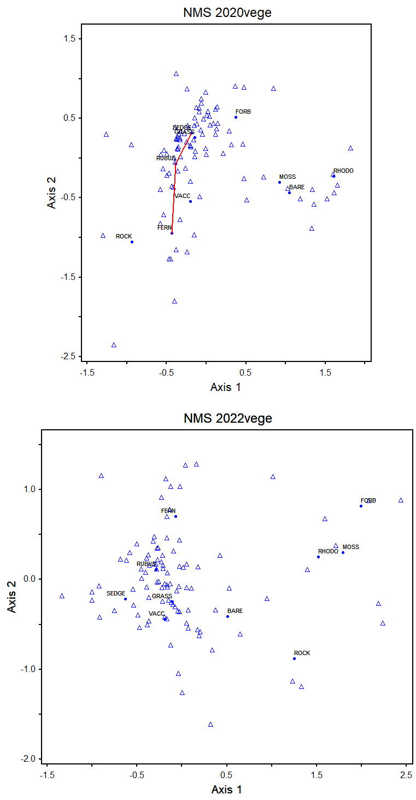

Figure 2. NMS distribution of plots in 2020 (Top) and 2022 (Bottom)

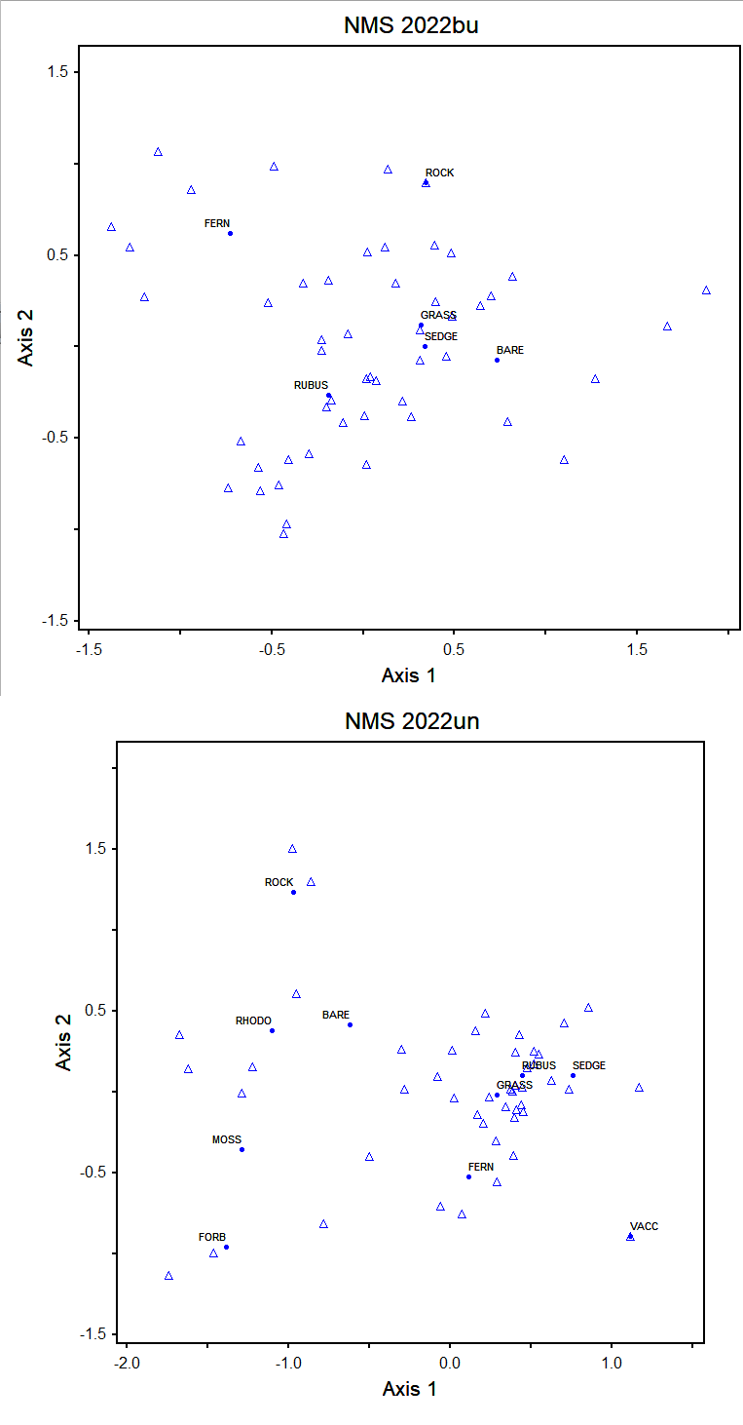

Figure 3. NMS distribution of plots in burned plots (top) and unburned plots (bottom) in 2022A graph of a graph of a graph of a graph of a graph of a graph of a graph of a graph of a graph of a graph of a graph of a graph of a graph of

Figure 4. Dominance diversity curves of all vegetation cover types for all plots in 2022 (top) and 2020 (bottom).

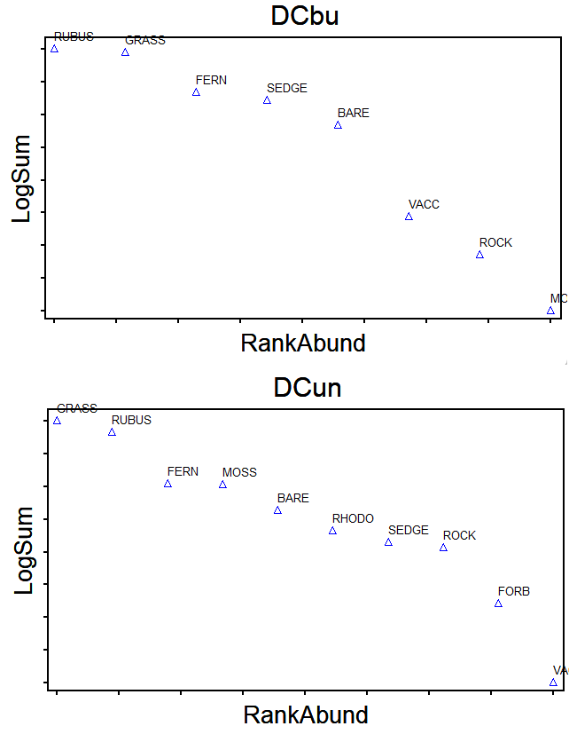

Figure 5. Dominance diversity curves for all vegetation cover types for burned plots (top) and unburned plots (bottom) in 2022.

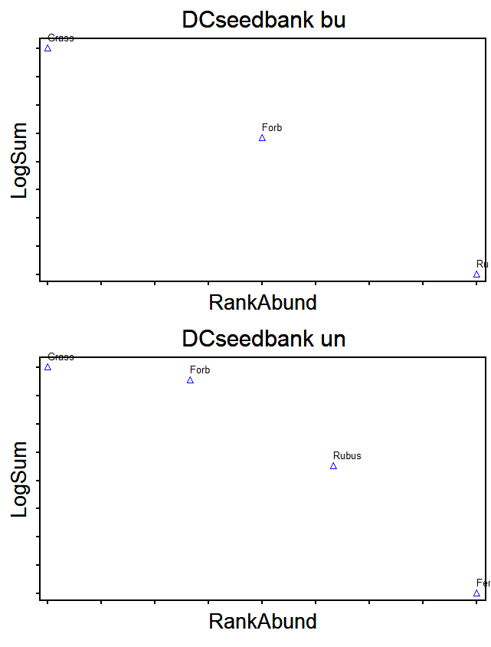

Figure 6. Dominance diversity curve for the seedbank in burned plots (top) and unburned plots (bottom) in 2022.